Home BP Recording
Full Name: ______________________________________________
DOB: ________________________
Record BP At home for 7 consecutive days. Each day take 2 morning readings (at least 2 minutes apart) and then 2 evening readings (at least 2 minutes apart), whilst seated.
At the end of the week you will then have 28 readings. Calculate the average of these 28 readings – this is the number we will base treatment on.
 |  | Systolic (Top Number) | Diastolic (Bottom Number)
Monday | Morning
Monday | Morning
Monday | Evening
Monday | Evening
Tuesday | Morning
Tuesday | Morning
Tuesday | Evening
Tuesday | Evening
Wednesday | Morning
Wednesday | Morning
Wednesday | Evening
Wednesday | Evening
Thursday | Morning
Thursday | Morning
Thursday | Evening
Thursday | Evening
Friday | Morning
Friday | Morning
Friday | Evening
Friday | Evening
Saturday | Morning
Saturday | Morning
Saturday | Evening
Saturday | Evening
Sunday | Morning
Sunday | Morning
Sunday | Evening
Sunday | Evening
Average
(Total of the readings divided by the number of readings)

8 Steps to Ensure an Accurate Blood Pressure
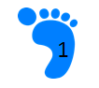Taking a BP over clothing can increase the measurement by 
10-40mmHg
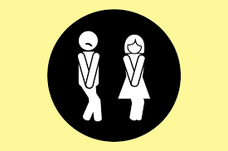
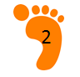 A full bladder adds 10 – 15mmHg

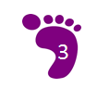 Talking can add 10 – 15mmHg
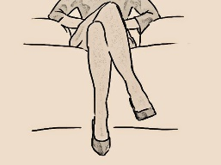
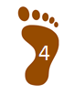 Crossed legs can add 2 – 8mmHg
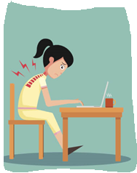
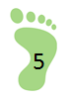 An unsupported back can add 5 – 10mmHg
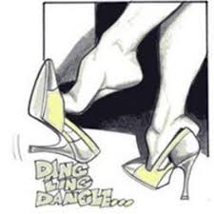
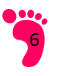 Unsupported feet can add 5 – 10 mmHg
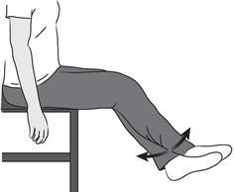
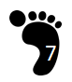 Unsupported arm can add 10mmHg – If arm below heart level
readings too high. If arm above heart level readings will be too low

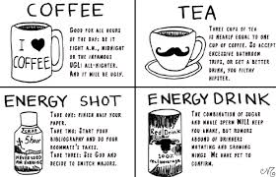
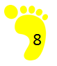Avoiding Caffeine, smoking and Exercise for 30 minutes
before checking BP can ensure an accurate reading

