**Home BP Recording**

Full Name: ______________________________________________

DOB: ________________________

Record BP At home for 7 consecutive days. Each day take 2 morning readings (at least 2 minutes apart) and then 2 evening readings (at least 2 minutes apart), whilst seated.

At the end of the week you will then have 28 readings. Calculate the average of these 28 readings – this is the number we will base treatment on.

|  |  |  |  |
| --- | --- | --- | --- |
|  |  | **Systolic (Top Number)** | **Diastolic (Bottom Number)** |
| Monday Date: ____________ | Morning |  |  |
| Morning |  |  |
| Evening |  |  |
| Evening |  |  |
| Tuesday Date: ____________ | Morning |  |  |
| Morning |  |  |
| Evening |  |  |
| Evening |  |  |
| Wednesday Date: ____________ | Morning |  |  |
| Morning |  |  |
| Evening |  |  |
| Evening |  |  |
| Thursday Date: ____________ | Morning |  |  |
| Morning |  |  |
| Evening |  |  |
| Evening |  |  |
| Friday Date: ____________ | Morning |  |  |
| Morning |  |  |
| Evening |  |  |
| Evening |  |  |
| Saturday  Date: ____________ | Morning |  |  |
| Morning |  |  |
| Evening |  |  |
| Evening |  |  |
| Sunday Date: ____________ | Morning |  |  |
| Morning |  |  |
| Evening |  |  |
| Evening |  |  |
| **Average**  *(Total of the readings divided by the number of readings)* | |  |  |

**8 Steps to Ensure an Accurate Blood Pressure**

**10-40mmHg**

[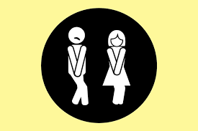](https://www.google.co.uk/imgres?imgurl=https://www.rd.com/wp-content/uploads/2017/09/01-Medical-Reasons-Why-Youre-Peeing-a-Lot-1024x683.jpg&imgrefurl=https://www.rd.com/health/conditions/peeing-a-lot/&docid=igb2zbZFe42wAM&tbnid=INWUAcLaD8l4xM:&vet=12ahUKEwjzy5OY76fZAhWCzqQKHWUnBWI4ZBAzKBEwEXoECAAQEg..i&w=1024&h=683&bih=929&biw=1280&q=need%20a%20wee%20cartoon&ved=2ahUKEwjzy5OY76fZAhWCzqQKHWUnBWI4ZBAzKBEwEXoECAAQEg&iact=mrc&uact=8)A foot print with number two
A full bladder adds **10 – 15mmHg**

Talking can add **10 – 15mmHg**

[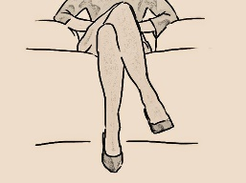](http://www.google.co.uk/url?sa=i&rct=j&q=&esrc=s&source=images&cd=&cad=rja&uact=8&ved=2ahUKEwj-jPHH9KfZAhXODuwKHRckD4kQjRx6BAgAEAY&url=http://www.psychmechanics.com/2015/05/body-language-crossing-legs.html&psig=AOvVaw1Htn2rXcHpH5KtbZKa0n42&ust=1518783650042886)A brown foot print with white text
Crossed legs can add **2 – 8mmHg**

An unsupported back can add **5 – 10mmHg**

[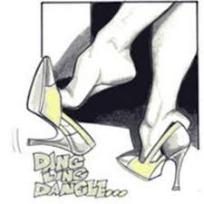](https://www.google.co.uk/imgres?imgurl=https://yt3.ggpht.com/a-/AJLlDp2-DZSBarq-vfN417omICNAS_AJRCAnpOt1FQ%3Ds900-mo-c-c0xffffffff-rj-k-no&imgrefurl=https://www.youtube.com/channel/UCv6iyuGXY2XyD6ueEKcUwQw&docid=FEHz6knay31kDM&tbnid=TJGmn_Ckg2qYwM:&vet=10ahUKEwi-m6b696fZAhVF16QKHT59AIoQMwh5KDIwMg..i&w=900&h=900&bih=929&biw=1280&q=dangling%20feet%20images%20cartoon&ved=0ahUKEwi-m6b696fZAhVF16QKHT59AIoQMwh5KDIwMg&iact=mrc&uact=8) A pink foot print with a number
Unsupported feet can add **5 – 10 mmHg**

Unsupported arm can add **10mmHg** – If arm below heart level

readings too high. If arm above heart level readings will be too low

Avoiding Caffeine, smoking and Exercise for **30 minutes**

before checking BP can ensure an accurate reading